Business Cards

How to Order Business Cards

Schedule for Delivery: Business Cards are printed twice a month. Orders submitted by the 13th of the month deliver to Cal Poly Distribution Services by the 20^{h}. Orders placed by the 28th of the month deliver by the 5th of the following month.

- Go to Boone Graphics’ Online Portal for Cal Poly
https://calpoly.myprintdesk.net/

- If this is your first time ordering with Boone Graphics’ site, you will need to set up a new account. Click on the “Log-In” link at the top, right of the page.

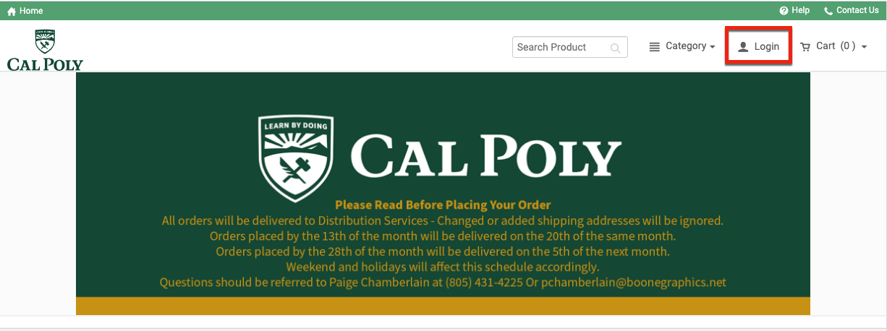
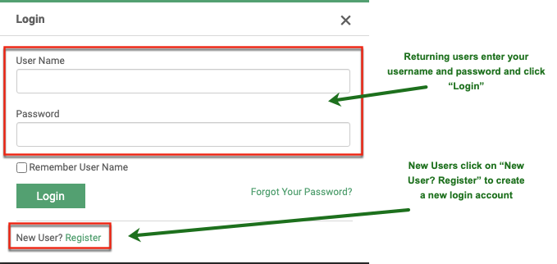
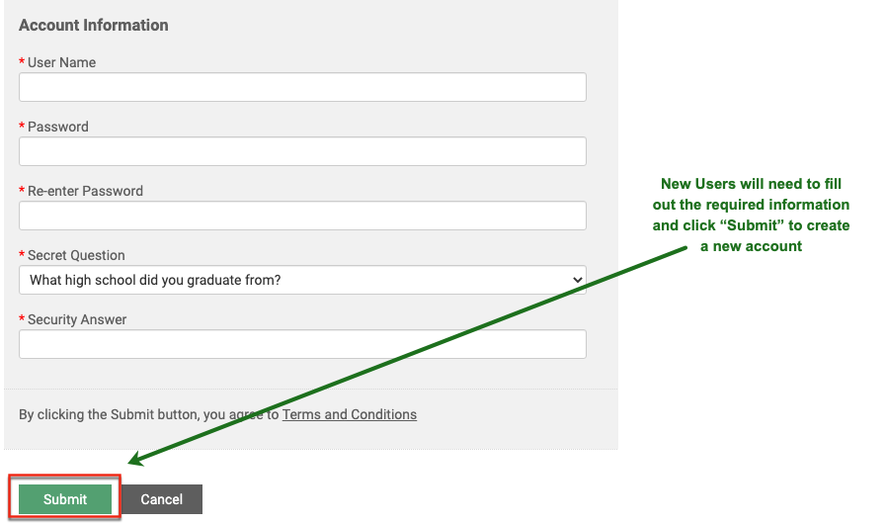

- After registering your new User account, you will be taken to your Home Page, where you will see Cal Poly Business Cards as a Featured Product.
- To order business cards, click “Buy Now” on the Business Card product. the template list to select the business card template you need for your department’s order(s). You may order several cards and add them to your shopping cart prior to placing your final order at checkout.
- Create a name for the Business Card order and select your desired quantity, then fill in the applicable detailed card information. You will be able to see the updated information populate onto your digital business cards in real time.
- You will be required to fill in an Account Code, Fund, Dept. ID, these are mandatory fields and are required for each standard Cal Poly business card order. Optional Program, Class, and Project Information needs to be provided if applicable.
- Click “Add to Cart” then “OK” to preview a proof of your business card before adding your card to the shopping cart.
- Preview your order in the shopping cart and either continue shopping to add an additional card to your order or click on “Proceed to Checkout” to complete your order.
- All orders are delivered to Distribution Services Bldg. 82. Do not add a different shipping address to your order.
- If you have additional comments or instructions enter them in the Delivery Instructions box.
- Click on “Proceed to Payment” to enter the Purchase Order for your order.
- Click on the “Place My Order” and an E-Mail will be sent to you confirming your order.

Please note: Swanton Pacific and Office of the President cards have custom templates. Please contact Page Chamberlain at 805-431-4225 or pchamberlain@boonegraphics.net for custom template pricing.

Standard Cal Poly green and black business cards cost:
- $27 for 100
- $30 for 250
- $34 for 500

There will be a $20 revision fee after the order has been created and placed online. Please be sure your order is correct prior to submitting.

Contact

Paige Chamberlain
Boone Graphics Cal Poly Representative
Cell: 805-431-4225 (preferred)
Office: 805-683-2349 ext. 123
pchamberlain@boonegraphics.net

If you are in need of an alternate design, contact: designsupport@calpoly.edu: 805-756-5635

