Attachment 9.2 - Injury & Illness Prevention Program
SAMPLE - Job Safety Analysis Form
University Union, Building 065, Flat Roof various levels
Picture of task/equipment: |  | Date: |  | 04/26/2019
 |  | Program : |  | Fall Protection
 |  | Analyzed By: |  | EH&S – Tim Hastings
 |  | Bldg: |  | University Union, Bldg. 65
 |  | Task: |  | Performing maintenance work on roof and on roof mounted equipment at University Union.  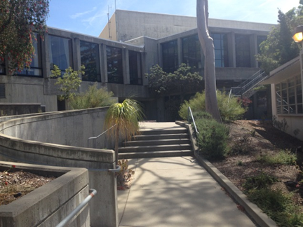
General Fall Protection Requirements:
1) Anyone working on a roof must have a means of requesting assistance either by radio, cell phone, or direct visual/audio contact with a co-worker with a radio or cell phone.
2) Prior to any roof work requiring fall protection or subject to a fall protection plan, personnel must confirm that they can contact University Police Dispatch (805) 756-2281. Use 911 for actual emergencies only.
3) Any roof work, requiring fall protection or subject to a fall protection plan, must be done by a minimum crew of two people.
4) Prior to work using fall protection equipment, verify 6 month competent person inspection is done on personal equipment and roof system.

Required Training:
Fall Protection: Authorized User or Competent Person Training as described in Cal Poly Fall Protection Program.
Required PPE:
1) Personal fall arrest harness
2) Fixed Lanyard- for doing equipment maintenance or
3) Self-retracting lanyard- maintenance tasks that require more mobility
4) Suspension trauma strap

TASK | HAZARDS |  | CONTROLS
Access to Roof: | Roof Hatches in Rooms 215 and 301A |  | - Use caution when transitioning through hatch opening.  - Close hatch, but do not latch, once on roof.
TASK | `HAZARDS |  | CONTROLS
Access to Roof.  Climbing ladder between various roof levels. | Possible fall while climbing ladder. |  | Climb while facing ladder.  Use both hands to grip ladder when climbing.  Do not carry anything by hand up or down the ladder.  Wear non-slip footwear.  Climb/descend the ladder using 3 point contact method.
Working on or near roof edge. | Fall from roof when working less than 6 feet from the edge of roof. |  | 1) Utilize personal fall protection equipment:  - fixed roof anchor,  - full body harness,  - fixed lanyard for work doing equipment maintenance  or  - self-retracting lanyard for work/tasks that require more mobility on roof  2) Inspect all fall protection equipment before use, by user and record inspection in Fall Protection Notebook.  3) Check label for competent person inspection within last 6 months.
Working around open access hatches. | Fall from roof to a lower level when working less within 6 feet of an open hatch. |  | 1) Close hatch, but do not latch, after exiting the hatch. This removes the fall hazard.  OR  2) Utilize personal fall protection equipment:  - fixed roof anchor,  - full body harness,  - fixed lanyard for work doing equipment maintenance  or  - self-retracting lanyard for work/tasks that require more mobility on roof  3) Inspect all fall protection equipment before use, by user and record inspection in Fall Protection Notebook.  4) Check label for competent person inspection within last 6 months.
Attachment into CB12 anchor point by user: | Disengagement of snap hooks, carabiners or other connectors. |  | 1) Connectors must be compatible with CB Anchors:  - self-locking and self-closing  2) All connectors must be inspected by user prior to use and by competent person every 6 months.  3) Connector must be closed and locked to D-ring  4) Snap hooks and carabineers must not be connected to one another.  5) Only one connection per D-ring
Working with tools at elevated heights: | Falling tools or equipment to ground level where bystanders may be located: |  | 1) Maintain tools in a location away from the sides of the building.  2) If working near the edge of a building with tools and equipment; demarcate the area below to restrict access.
Unprotected edges:  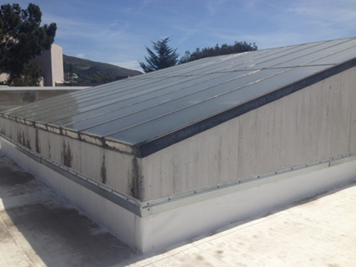  < 42 inches from roof surface, stay 6 feet away. | Unprotected/unguarded edge at skylight on roof. |  | 1) No work should be done within 6 feet of skylight on sections where the skylight is less than 42 inches height from roof surface.
Site Specific Hazards: | ☐ Low Light  ☒ Trip Hazards  ☐ Hidden Drop-offs  ☐ Unstable Footing  ☒ Slippery Surfaces  ☒ Protruding Objects ☐ Moving Parts  ☐ Pedestrian Traffic  ☐ Open Floor Holes  ☐ Floor Openings ☐Sloping Surfaces  ☐ Unstable Surfaces ☒ Skylights  ☐ High Wind Velocity  ☐ Weather Related  ☐ Other__________ |  | Use caution when walking. Wear non-slip shoes/boots.  Watch for protruding object and other trip hazards.  Keep at least 6’ away from skylights unless wearing fall protection and connected to an approved anchor point.

