CMS Business Process Guide
Addresses and Names

This guide explains the various fields or “data elements” located on the Addresses and Names pages. Address and name changes may be viewed by clicking on the arrows in the title bar.

- Addresses
- Names

Main Menu > Workforce Administration > Personal Information > Modify a Person
- Addresses
Back to top
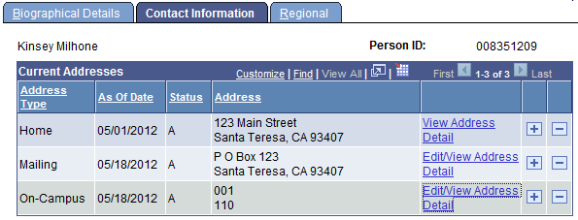

Address Type | Identifies the type of address  - Home address is the residence address.  - Mailing address is used for W-2 and other official purposes. If no Mailing Address is displayed, Home address is used.
As of Date | Date address was entered in PeopleSoft
Status | Status of address
Address | Address
Edit/View Address Detail | Click on link to view future or historical rows

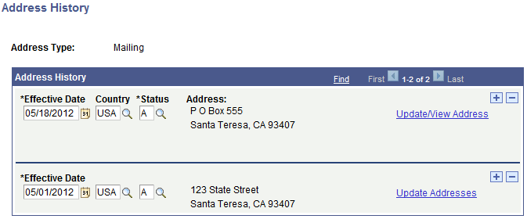

- Names
Back to top
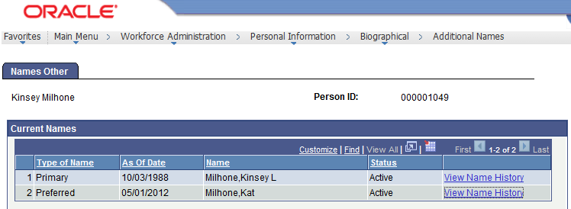

Type of Name | Identifies the type of name for the employee  - Primary Name is the name that appears on the Social Security card and is used for payroll purposes.  - Preferred Name is used for Cal Poly correspondence; if no Preferred Name is displayed, Primary Name will be used.
As of Date | Date the name was entered in PeopleSoft
Name | Name of the employee
Status | Status of Name
View Name History | Click on link to view future or historical rows

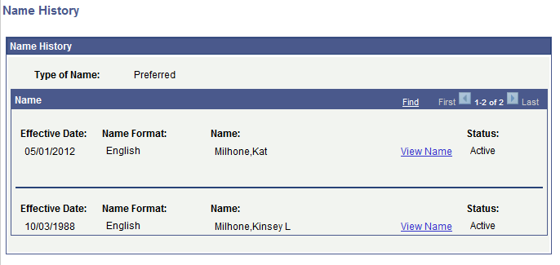
Back to top

