CPU003_primary_logo_PMS349U

Employee

Timesheet Entry

*Payroll Services*

PeopleSoft Version 9.0

Table of Contents

[1.0 Accessing Employee Timesheet 3](#_Toc417633762)

[2.0 Timesheet Overview 3](#_Toc417633763)

[3.0 Select Time Reporting Code 4](#_Toc417633764)

[4.0 Enter Hours for Pay 5](#_Toc417633765)

[5.0 Submit Hours 5](#_Toc417633766)

# Accessing Employee Timesheet

Employees access their timesheet using Self-Service>Time Reporting>Report Time>Timesheet in PeopleSoft. A direct link to this page has been provided on the “Personal Info” tab of the My Cal Poly Portal. To navigate there, please follow these steps:

1. Open a web browser (Internet Explorer, Firefox, etc.) and type [my.calpoly.edu](file:///\\afd-nas-04\DeptData\Payroll\PSoft%20Absence%20Management%20Module\HCM%209.0\AM%209.0%20Upgrade\HCM%209.0%20Absence%20Mgmt%20BPGs\Cal%20Poly%20Guides\my.calpoly.edu)

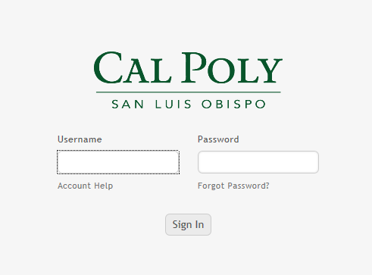

1. Enter your Cal Poly user name and password
2. Navigate to the “Personal Info” tab



1. Under “Employee Info” you will find the “My Pay and Leave Usage” section. Your timesheet is accessed by clicking on “Submit” next to “Submit Hours for Pay”:

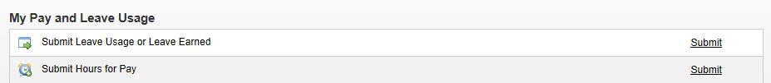

# Timesheet Overview

The purpose of **Timesheet** is to request hours worked for *Pay* from Payroll Services. You could be an hourly/intermittent employee requesting Regular (REG) hours or you could be a salaried employee requesting Overtime or Shift Differential (please note, if you are a salaried employee, you do not request REG hours for pay). Please see your department timekeeper if you are unsure when you need to use this page.

The page automatically opens up for you in the current week. So for instance if today was 3/25/15, you would see the view for the entire week of 3/23 through 3/29. For ease of use, it is recommended to change the “View By” from Week to Time Period:

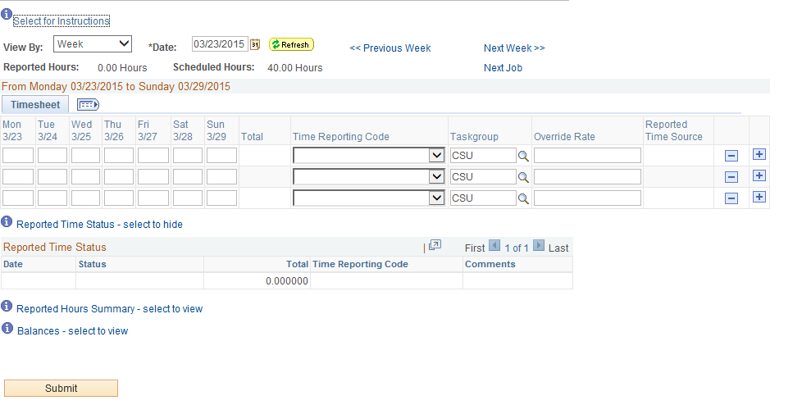

# Select Time Reporting Code

From the drop-down menu entitled “Time Reporting Code” select the appropriate payment type. You will only see selections that are appropriate to your employment with Cal Poly. **Tip**: Hourly/Intermittent employees should select “REG – Regular Hours Worked”.

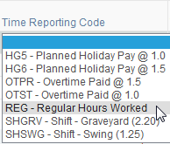

# Enter Hours for Pay

Each unique “Time Reporting Code” is reported on separate rows. Enter the value of hours worked in the box below the date worked. The example shows “REG” and “OTPR” entered:

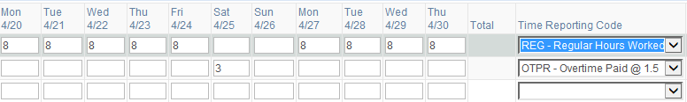

# Submit Hours

When finished, hit the “Submit” button.



There is no retroactive timesheet processing. Once the deadline has passed, you must submit a late timesheet. All hours must be entered by the first business day of the following pay period. See the payroll calendar for exact dates.

**Tip**: You may submit hours all throughout the month as you work. Payroll Services will not process your entries until the pay period is over, and your manager has approved them.