To start, log on to the portal using either Internet Explorer or Safari. Does not work well with Chrome or FireFox. | 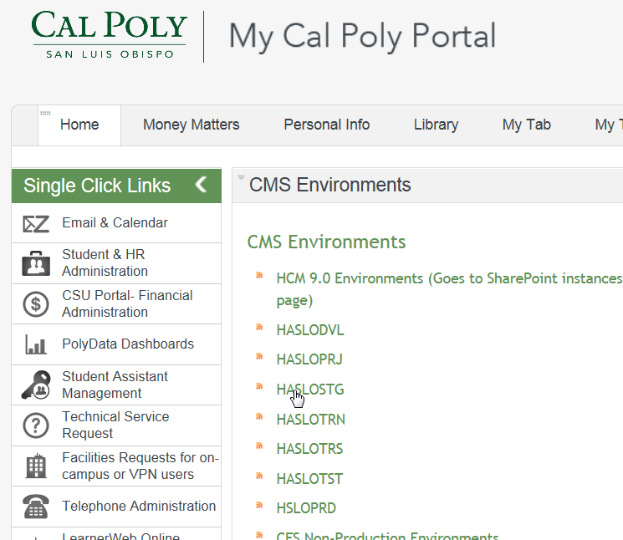
Select the CSU Procard link from either your Favorites or the Main Menu | 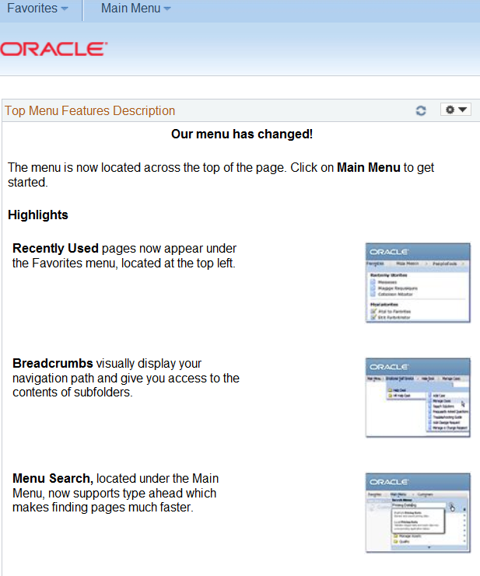
- CSU ProCard  - Use & Inquiry  - ProCard Adjustment | 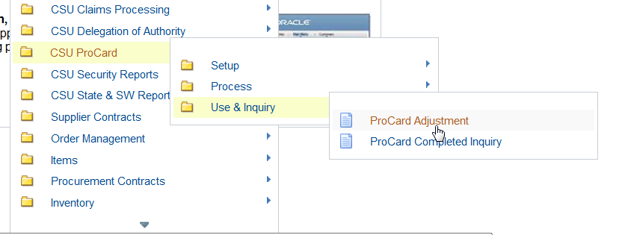
Enter in your Last Name  Select Search  NOTE:  If you have a ProCard and a Travel Card the Travel Card can be identified by the “T” in PeopleSoft Financials | 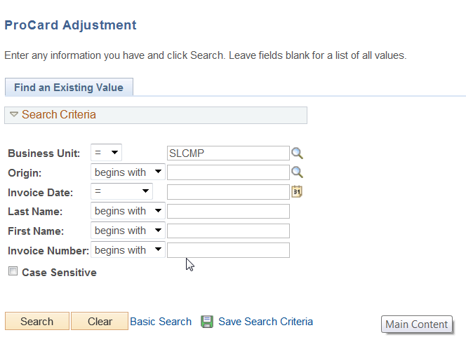
If you had more than one charge select View All  Be sure to write a detailed explanation of your charge such as last name and date of travel  If necessary change the chart of accounts by typing over existing information  Save your changes | 