GROUP MANAGER TUTORIALS

As a group manager you will be able to:
- View your cardholders transactions
- View declined transactions
- View your cardholder’s statements
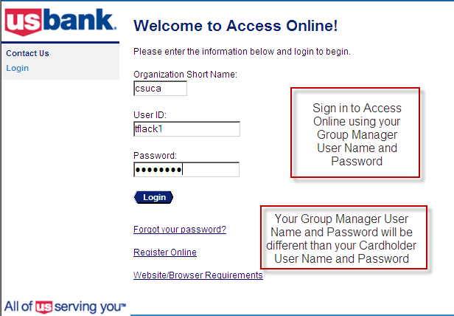

View your cardholder’s transactions.
- Transaction Management
- Transaction List
- Enter Cardholder Name
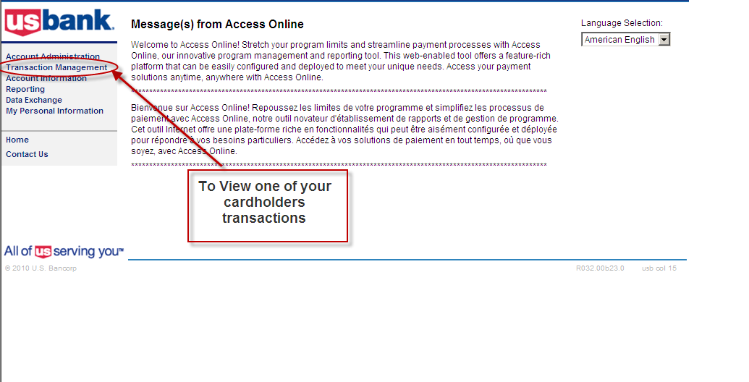
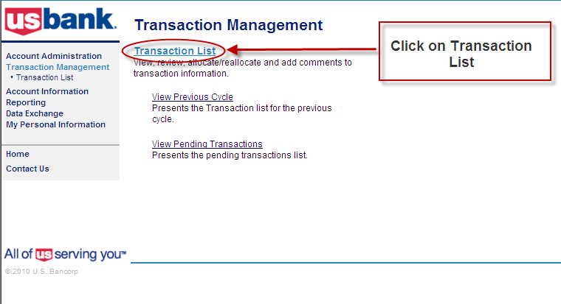
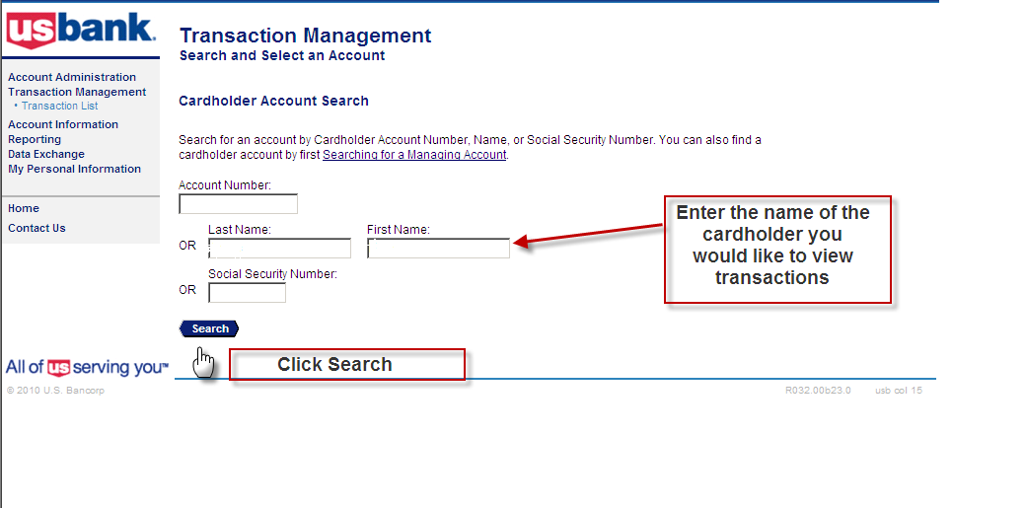
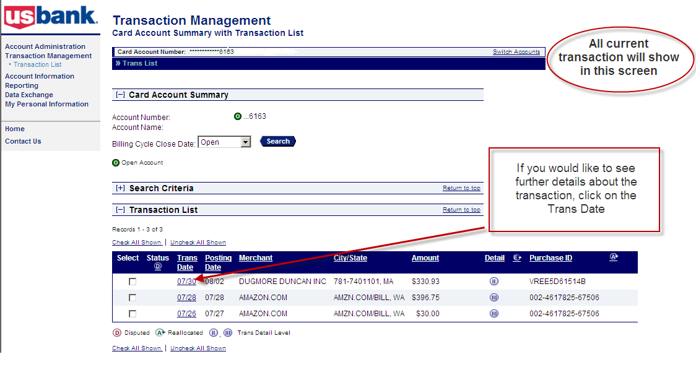
You will also be able select from the drop down box ALL transactions and CURRENT transactions
You will need to click on Switch Accounts to view other cardholder’s transactions within your group.
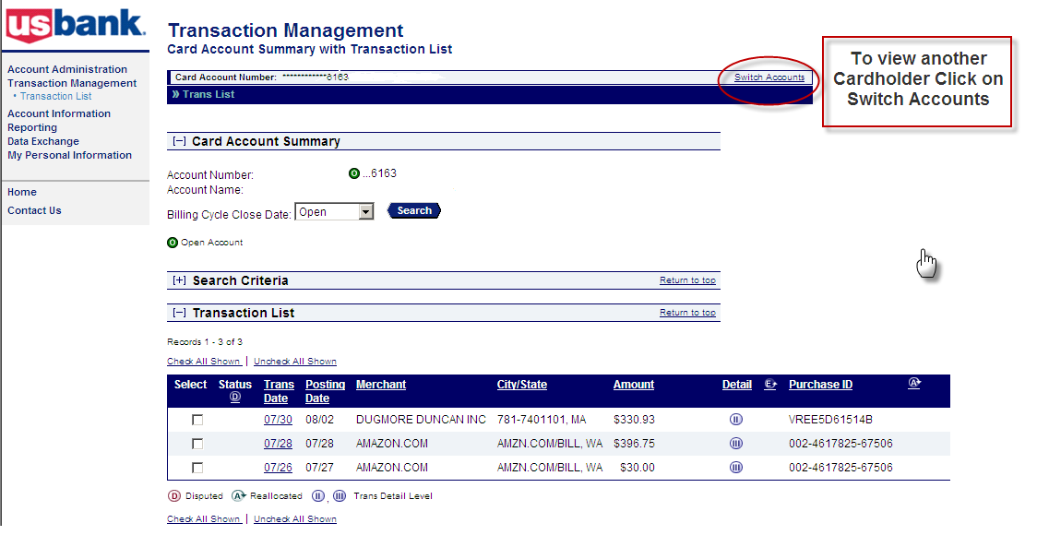

View declined transactions
- Go to your home page
- Account Information
- Cardholder Account Profile
- Enter Cardholder Name
- Account Authorizations

