ACCESSING APPROVALS IN CONCUR USER GUIDE

APPROVER GUIDE - Approving
This guide will show approvers how to approve and/ or approve and forward Requests and Expenses, since both follow the same process. It also explains how much time an approver has to approve the Request or Expense. Please make sure to read through the entire document.

Approver timing:
Approver has the following time to approve. After that time, it moves to the next in-line manager for their approval. They will then have the following time to approve and then it will move up, and continue to go up the chain to the President, therefore it is important to approve in a timely manner.
 | Cost Object Approver  (budget approver) |  | HR Manager
Type of Approval | Time in Queue | No action from approver, the system will | Time in Queue | No action from approver, the system will
Request | 6 days | Automatically approve and it moves to HR manager | 6 days | Automatically move to the next in-line manager
Expense | 10 days | Automatically approve and it moves to HR manager | 10 days | Automatically move to the next in-line manager

Approval flow - Requests:
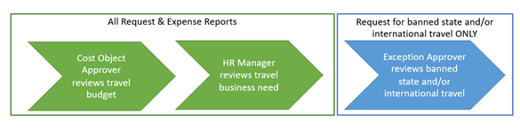

Approver can approve 3 ways:
- Email – approver receives email and clicks on link
- Login directly to Concur online tool
- Mobile App

- APPROVE VIA EMAIL
Once your direct report submits a Request or Expense Report you will receive an email.

- Click on the link in email (if approver does not get email, check junk folder)
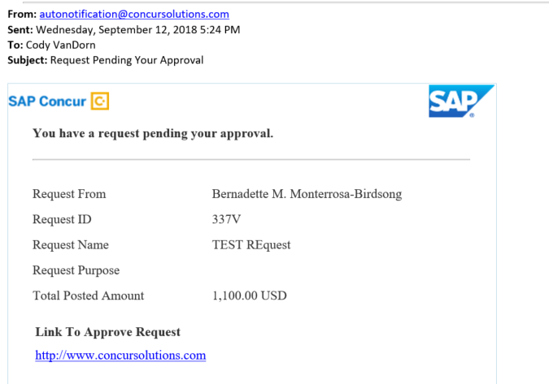
- CSU select campus page opens. Select “San Luis Obispo” for your campus & click on “Login”
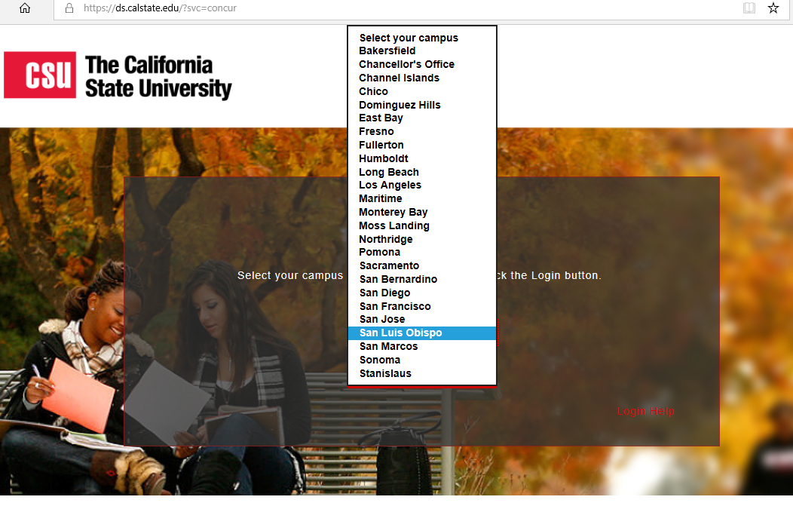

- Sign on with Cal Poly single sign on
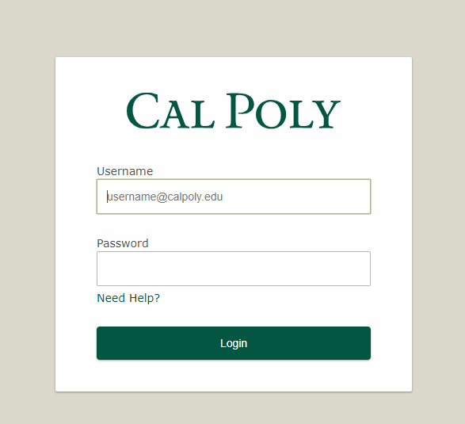

- Concur opens. To review submissions you will need to go to Approval Home page, to do so, you can either…
  - Click on Required Approvals below black bar;
  - Scroll down to MY TASKS and click on Request Approvals or Available Expenses to go to Approval Home page; or
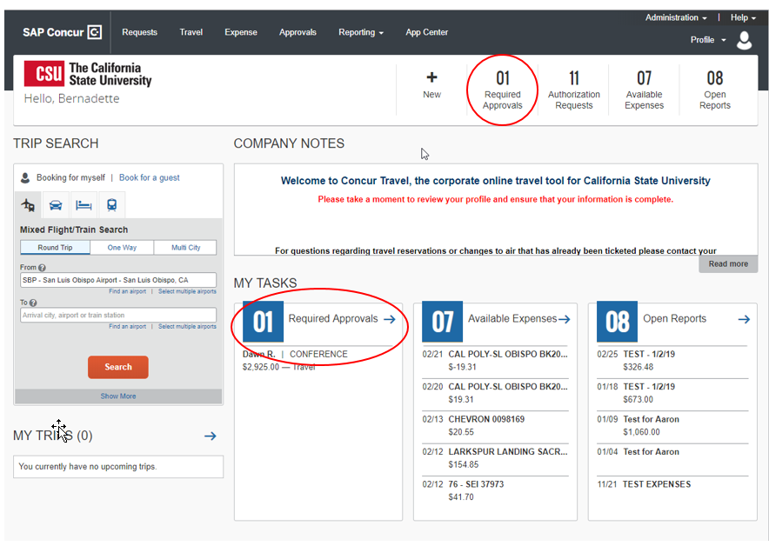

  - Click on Approvals on main tab (black bar)

- On Approvals Home, click on either Requests or Expense Reports tab. Find the Request or Expense Report you want to review. Click on either the name or ID to access the details. 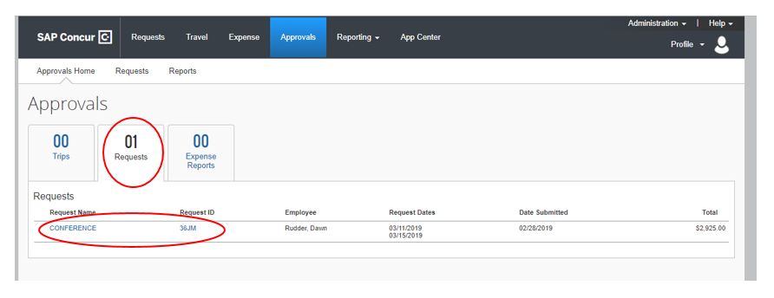

- Request details open
  - Request Header provides trip information, such as dates and type of travel
  - Expense Summary tab provides budget information
  - Attachments button will allow you to see any documents attached to the Request

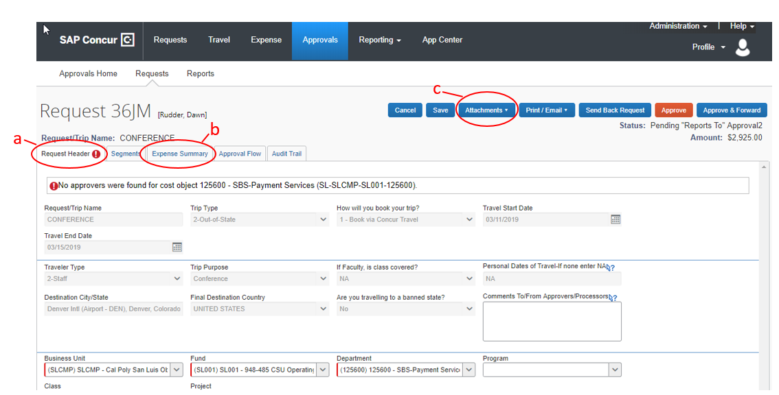

- APPROVE VIA CONCUR TOOL
- Login to my.calpoly.edu portal
- Click on Concur Travel (left side)

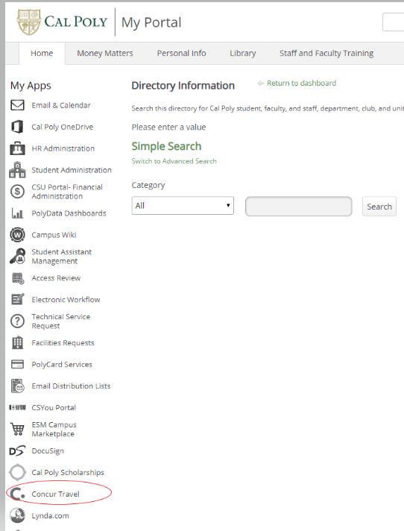

- Concur opens and click on Approvals (same box for Requests and for Expense Report Approval)
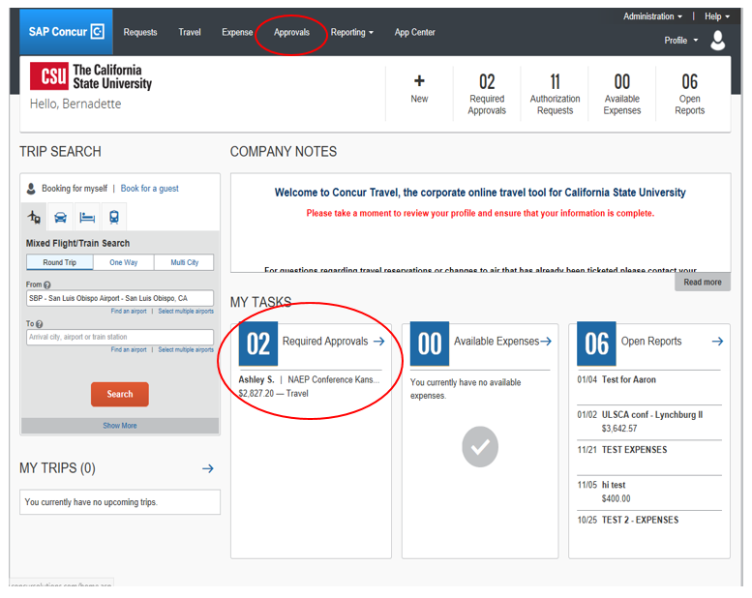

- APPROVE VIA MOBILE APP
- Open app (See mobile app guide to download app)
- Select Approvals
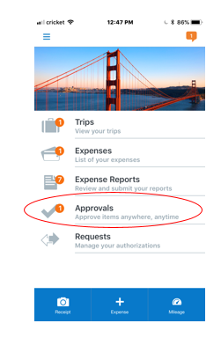

- Select what you want to review, Request or Expense
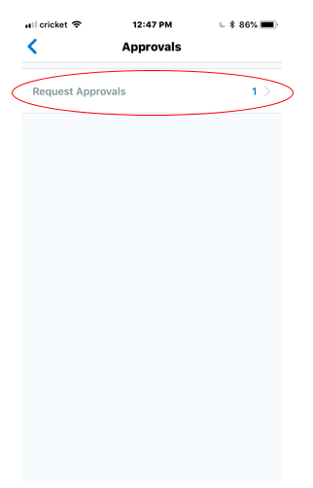

- Select the specific Request or Expense Report you want to review
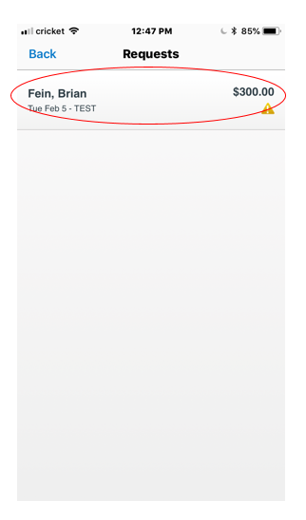
- Click on each expense type to review detailed information
- If you have questions or concerns, click on Send Back; type your question or concern and the Request or Expense Report will go back to the traveler along with your comments. They will need to resubmit.
- If you approve, click on Approve
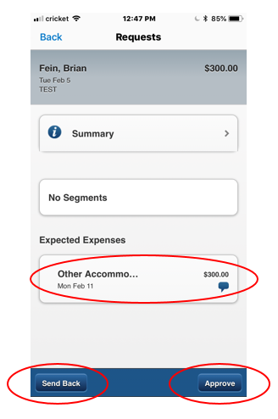

Questions? Contact the Poly Travel office at PolyTravel@calpoly.edu or 805-756-2232

