REVIEWING & APPROVING REQUESTS IN CONCUR USER GUIDE

This guide will show approvers how to review and approve and/ or approve and forward Requests. Please make sure to read through the entire document.

Approval Flow and Timing:
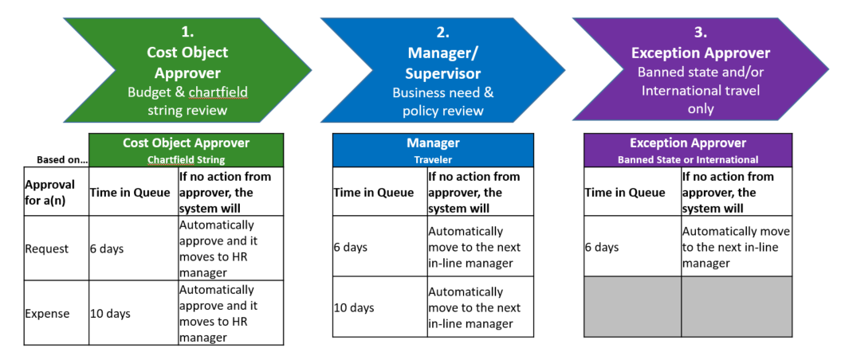
To Review and Approve:
Once your direct report submits a Request or Expense Report you will receive an email.
- Open the Request you want to review (see Accessing Approver Guide)
- To review Request details open
  - Request Header tab provides trip information, such as dates and type of travel
  - Expense Summary tab provides budget information
  - Attachments button will allow you to see any documents attached to the Request
  - If banned state travel requested, Comments section will provide justification for travel to the banned state

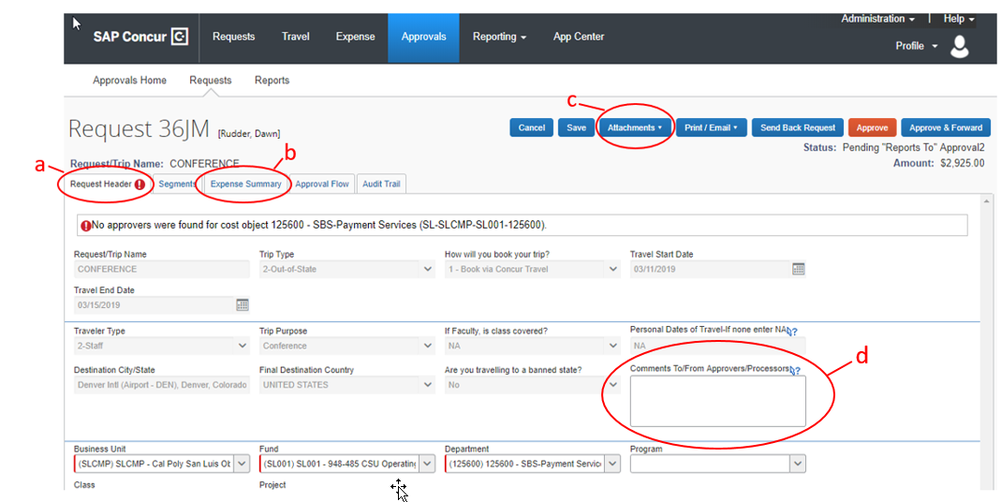

- Click on Expense Summary tab. Click on each line to review details for expense; expense will highlight to light blue and details will appear in right gray box. Total amount being requested will appear at the bottom. Remember this is ONLY a budget.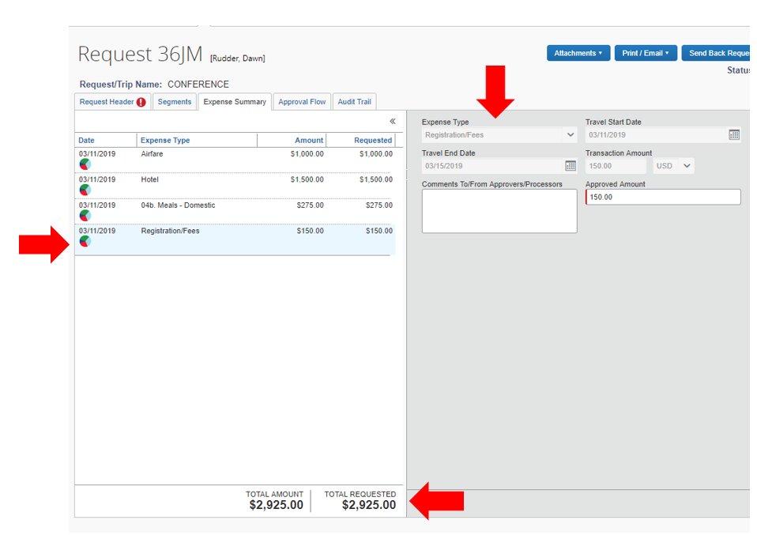

Reviewing and /or Updating Allocations
- Click on pie icon to review allocation information. The icon will only appear if allocation is different than the chartfield string in header.
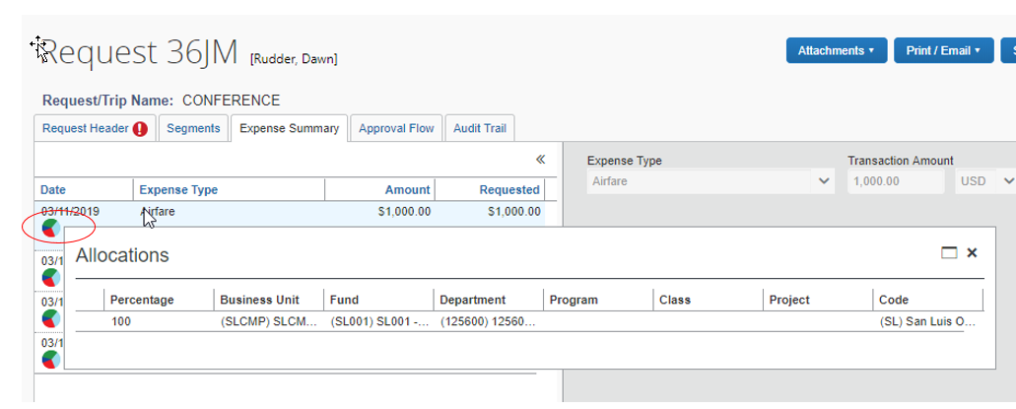

- To change chartfield string, click on individual expense and click on Allocate
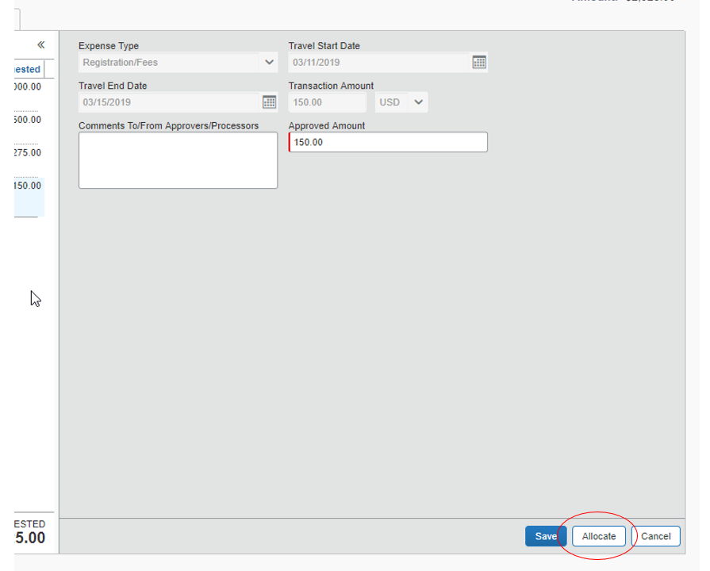

- You can Add New Allocation and allocate Percentage of allocation to each chartfield string or change chartfield string by typing number (best way to search, do not recommend text search) in appropriate box. Click Save
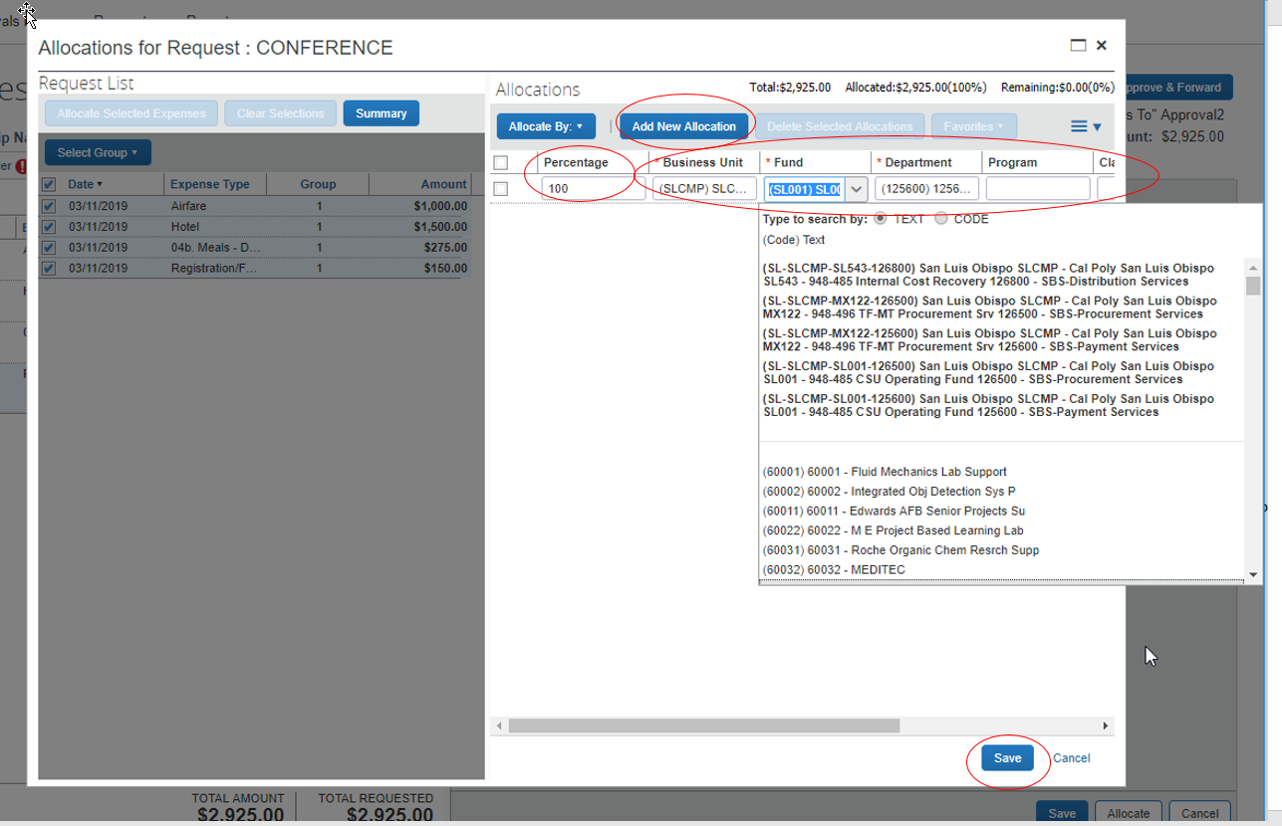

- Click on…
Send Back Request | To send back to traveler. Make sure to include note for why it is being sent back. Re-submitted Request will go through entire approval process each time
Approve | To approve Request so traveler may book their travel
Approve & Forward | To approve and forward Request to another Manager (can only forward to manager level)
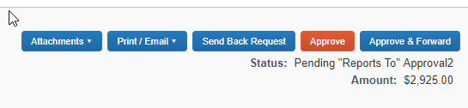

NOTE: Requests are for budget purposes.

Questions? Contact the Poly Travel office at PolyTravel@calpoly.edu or 805-756-2232

