ASSIGNING DELEGATES IN CONCUR USER GUIDE

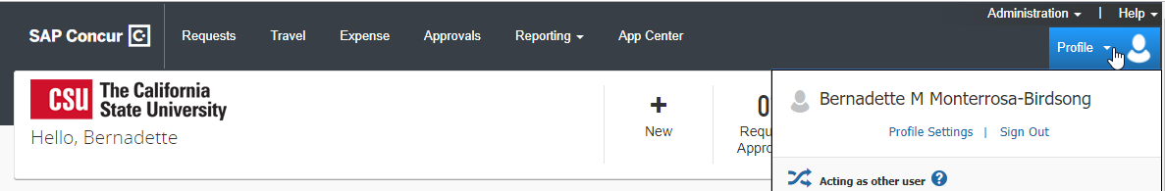

This guide will show you how to assign a Delegate to:
- prepare Request and Expense Reports
- review incoming Requests and Expense Reports for approval
- receive your emails from the system
- pull travel reports on your direct reports

- Go to your Profile Settings
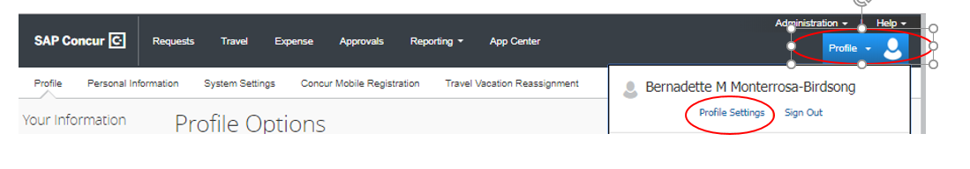
2. Go to Request Delegate or Expense Delegate (note, what you do in Expense will be reflected in Request, therefore you only have to set up the person once and they will be delegate for both Request and Expense)
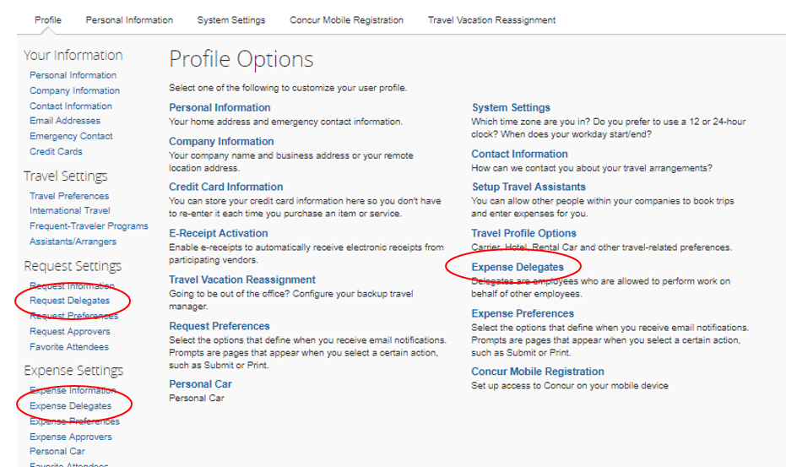

3. In Expense Delegates, Click on Add
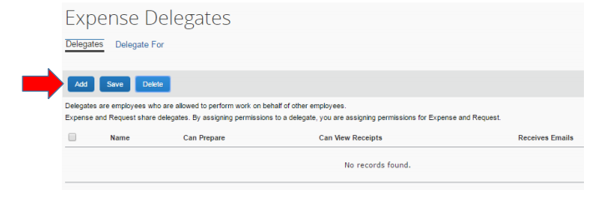
4. Type a few first letters of the last name of the employee you would like to delegate (the person must have a Concur profile).
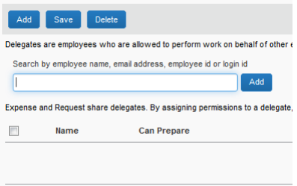
5. Select the permissions you want your delegate to have and then click the Save button, next to Add button
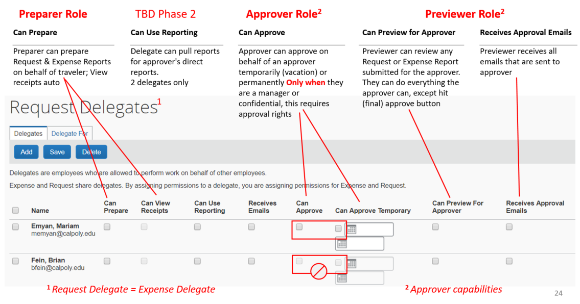
6. Once the employee is selected and the permissions granted, the employee can now act on behalf of the traveler for Request and Expense (see Delegated employee for details)

AFTER DELEGATE PREPARES A REQUEST AND/OR EXPENSE REPORT, YOU WILL BE NOTIFIED
- You will receive an email notification
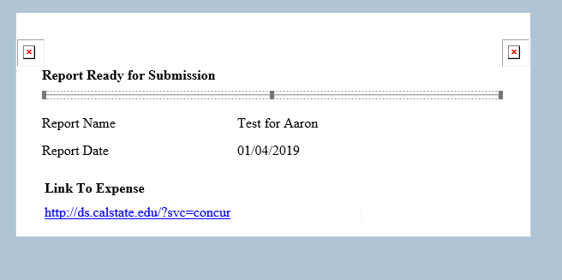
- For Requests, go to Manage Request queue, click on the icon to see the prepared Request. Upon review, click on Submit.
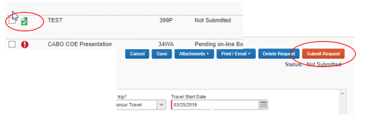
- For Expense Reports, go to Active Reports section in Expense, click on the Ready for Review icon. Upon review, click on Submit
