Correcting and Resubmitting an Expense Report



Your Expense Report Approver or processor will send a report back to you if an error is found. The Approver or Processor will include a comment explaining why the report was returned to you. To identify and correct expense reports requiring resubmission:

1. On the home page, in the Quick Task Bar, click the **Open Reports** tile. In the **Manage Expenses** section of the page, the report appears with **Returned** header on the report tile. The approver's comment appears below the amount.



2. Click the report tile to open the report.

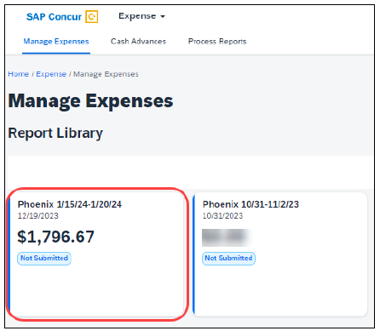

3. Make the requested changes – which could include adding receipts, comments, or documents.

4. Click “**Submit Report.”**